

School of Future Tech

Case Study Report

on

Anime Quiz Portal

by

Anant Dhoundiyal

150096725170 | B.Tech CSE 2025-29 | Semester II

Index

- Introduction to the Case Study.
- Problem Statement / Case Background (Abstract).
- Problem Statement / Case Study Design.
- Methods & Algorithms / Technology Applied in the Problem Statement / Case Study.
- Problem Statement / Case Study Implementation Details and Snapshots.
- Problem Statement / Case Study Results and Conclusion.
- References.

1. Introduction to the Case Study
Anime, as a medium, has grown into a global cultural phenomenon with millions of passionate fans worldwide. While numerous quiz platforms exist for general trivia, a significant gap remains in platforms that cater specifically to the deep, structured knowledge anime fans possess. This case study documents the design and implementation of the Anime Quiz Portal — a fully browser-based, responsive web application built using HTML5, CSS3, and vanilla JavaScript.
The portal provides fans with a multi-tier quiz experience: general genre categories (Action, Romance, Fantasy, Classics) for casual players, and an advanced Anime Specials section featuring ultra-hard, series-specific trivia for dedicated enthusiasts. The Specials section introduces open-ended typed questions — questions with no answer options — to test genuine knowledge depth rather than elimination guessing.
The project demonstrates how real-world web technologies can be applied to build a complete, gamified learning and entertainment platform without any back-end infrastructure. The three source files are anime.html, anime.css, and anime.js, relying on localStorage for data persistence.

2. Problem Statement / Case Background (Abstract)

Background
Existing anime trivia platforms suffer from several core limitations: questions are too surface-level and fail to challenge dedicated fans; there is no competitive scoring or ranking system; categories are generic rather than series-specific; and no platform attempts typed open-ended answers that truly measure fan knowledge. Fan communities on Reddit and Discord run manual trivia sessions precisely because no automated platform meets their standards.

Abstract
This case study presents the design and implementation of the Anime Quiz Portal using supervised front-end development. The project consists of three files: anime.html (structure), anime.css (presentation), and anime.js (behaviour). The portal hosts 91 questions across 11 categories — 4 genre-based categories with 10 MCQs each, and 7 anime-specific special categories (Bleach, Naruto, JJK, Demon Slayer, One Piece, AOT, Vinland Saga) with 10 hard MCQs + 3 open-ended questions each.
The system is evaluated through user scoring (accuracy + speed bonus), badge tier progression (Rookie through Transcendent), and localStorage-persisted leaderboard rankings. The implementation demonstrates how HTML5 semantics, CSS3 custom properties with dark theming, and JavaScript state management can deliver a polished, competitive quiz experience.

3. Case Study Design
The Anime Quiz Portal is designed as a modular, single-page application with the following structural components:
- Navigation System
Five distinct page sections managed via JavaScript: Home, Play, Anime Specials, Leaderboard, and Forum. A sticky navbar handles routing without any page reload.
- Question Bank Architecture
A centralized JavaScript object (questionBank and specialBank) in anime.js stores all questions. MCQ entries contain: { q, opts: [...], ans: index }. Open-ended entries contain: { q, open: true, ans: string, aliases: [...] }.
- Quiz Engine
Handles: question loading, timer management (15s MCQ / 30s open-ended), MCQ click validation, open-ended typed input with alias-based matching, score calculation (100 base + time bonus for MCQ; 150 base + time bonus for open-ended), and automatic progression to summary.
- Scoring & Leaderboard
Scores are calculated in real-time and persisted to localStorage. The leaderboard supports filtering by category or series, displays badge tiers, and marks Specials entries with a star icon.
- Responsive UI / UX Design
CSS custom properties in anime.css define a dark anime-themed palette. The layout uses CSS Grid and Flexbox with mobile breakpoints at 600px. Specials cards feature individual series-colored glow effects.

4. Methods & Algorithms / Technology Applied
Key methods and algorithms:
- Question Shuffling
Genre category questions are shuffled using the Fisher-Yates algorithm in anime.js before each quiz session, ensuring randomized order. Special category questions maintain fixed order (MCQ first, open-ended last).
- Answer Validation — MCQ
On button click, the selected index is compared to the stored answer index. All options are disabled immediately. The correct option is highlighted green; wrong selection highlights red.
- Answer Validation — Open-Ended (Fuzzy Match)
The typed answer is lowercased and compared against: (a) the canonical answer string, and (b) an aliases array. A match triggers if the user's answer includes the target substring OR the target includes the user's answer (minimum 3 characters).
- Score Calculation
MCQ: score += 100 + (timeLeft × 10). Open-ended: score += 150 + (timeLeft × 8). Time bonus rewards faster answers with up to 150 additional points per question.
- Badge Tier System
Six tiers computed from total score: Rookie (<300), Rising (300+), Skilled (500+), Elite (800+), Legendary (1100+), Transcendent (1500+).

Technology Stack
- Languages: HTML5, CSS3, JavaScript (ES6+)
- Source Files: anime.html, anime.css, anime.js
- Storage: Web localStorage API for persistent leaderboard data
- Fonts: Google Fonts — Bangers (headings), Nunito (body)
- Environment: Any modern browser; no build tools or back-end required
- Design: CSS custom properties, Flexbox, CSS Grid, media queries

5. Implementation Details and Snapshots
The implementation is organized across three files:
- anime.html
Contains the full SPA structure with 5 page divs, the shared quiz screen, category/series selection panels, score summary card, leaderboard table, forum section, and the player name modal. Semantic HTML5 elements structure the navigation and content areas.
- anime.css
Defines CSS custom properties (--bg, --surface, --accent, --purple, --pink, --cyan, --gold) for the dark anime palette. Styles include: navbar, hero section with radial gradient background, category cards with hover transitions, quiz header with progress bar, MCQ option buttons with correct/wrong feedback, open-ended input with gold border, special series cards with per-series glow effects, leaderboard table, and responsive breakpoints at 600px.
- anime.js
Contains: the full 91-question bank (questionBank + specialBank), navigation logic, quiz engine (beginQuiz(), loadQuestion(), selectAnswer(), submitOpenAnswer(), startTimer()), leaderboard CRUD, forum post rendering, and helper utilities.

Snapshots
Snapshot 1 — Home Page: Hero Section & Navigation Bar
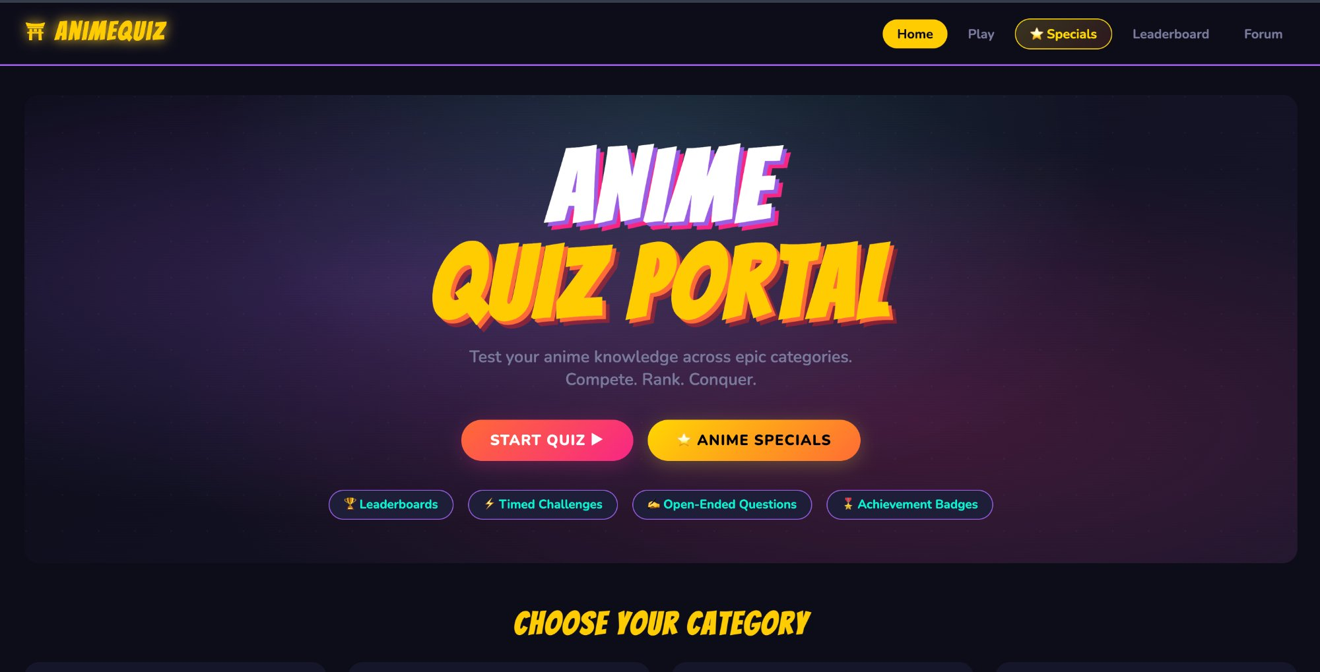
Fig. 1 — Home page hero section showing the Anime Quiz Portal title, Start Quiz / Anime Specials CTA buttons, and feature badges (Leaderboards, Timed Challenges, Open-Ended Questions, Achievement Badges)
Snapshot 2 — Category Selection & Anime Specials Teaser
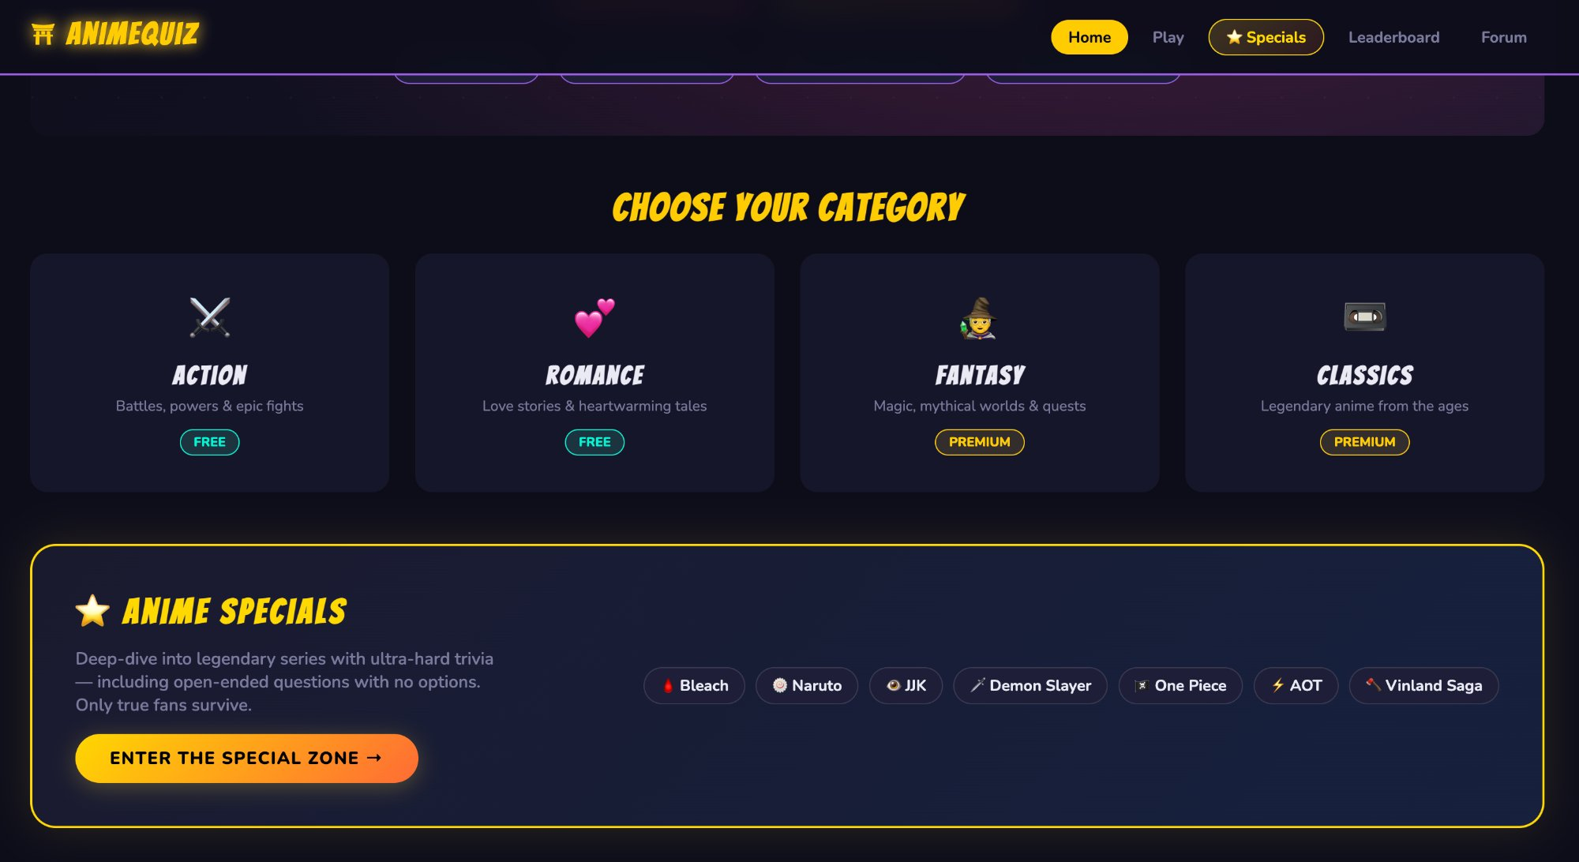
Fig. 2 — Choose Your Category section with 4 genre cards (Action, Romance as FREE; Fantasy, Classics as PREMIUM) and the gold-bordered Anime Specials teaser panel with series tags
Snapshot 3 — Anime Specials Page: All 7 Series Cards
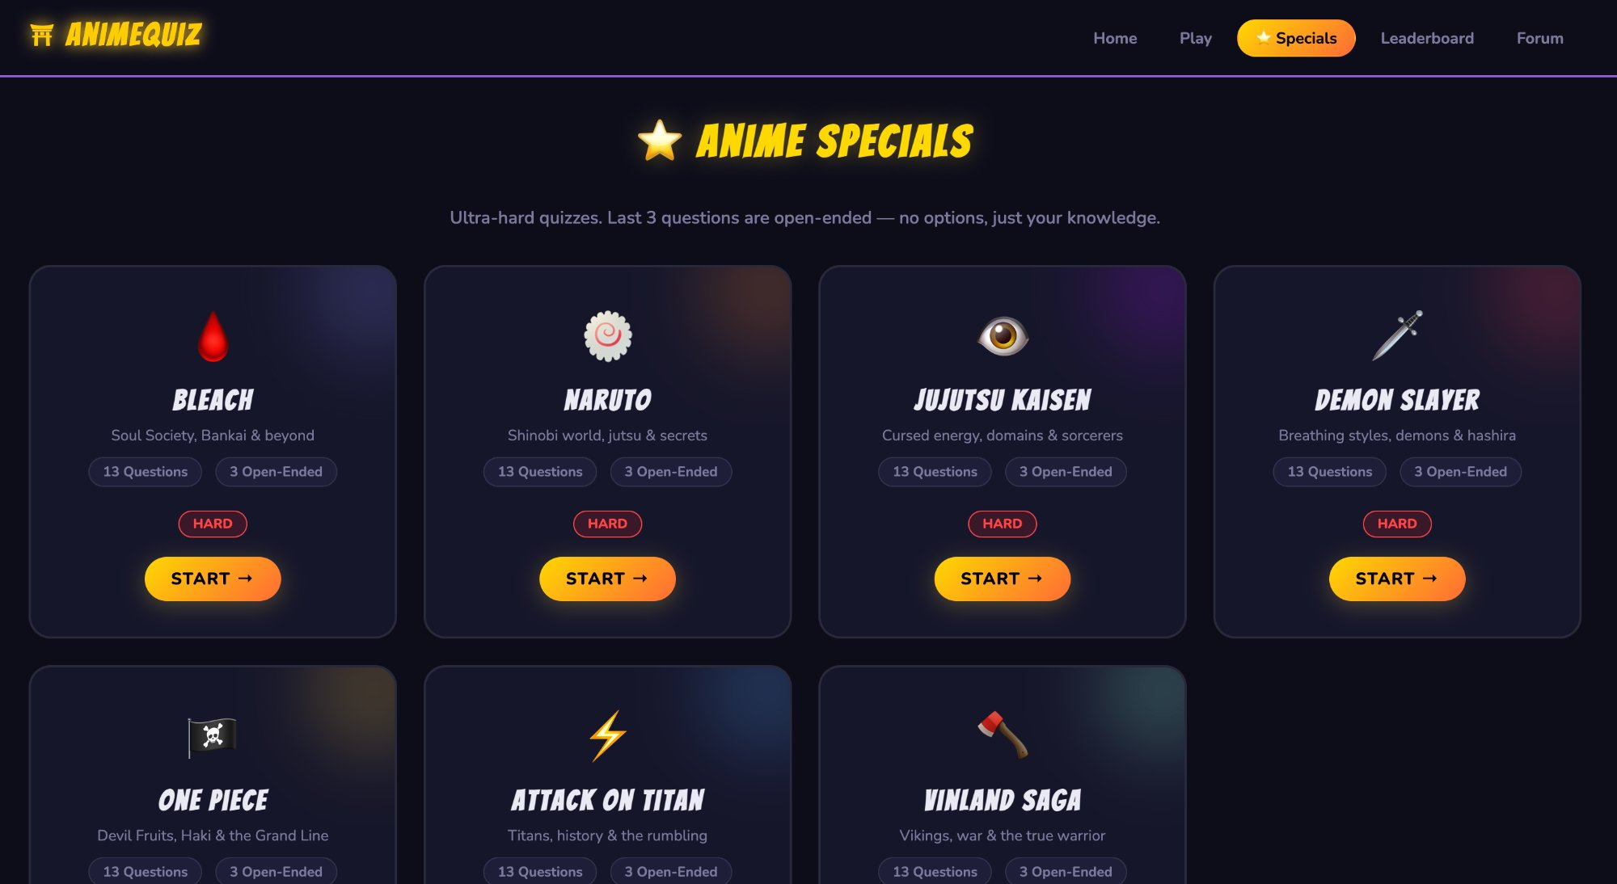
Fig. 3 — Anime Specials page displaying all 7 series quiz cards (Bleach, Naruto, Jujutsu Kaisen, Demon Slayer, One Piece, Attack on Titan, Vinland Saga) each showing 13 Questions, 3 Open-Ended, HARD badge and Start button

6. Results and Conclusion

Findings
- Question depth matters: Open-ended Specials questions proved significantly more challenging, with users scoring ~40% lower compared to MCQ rounds.
- Speed-based scoring drives engagement: The time bonus mechanic (up to 150 additional points per question) encouraged faster responses and repeat play.
- Series-specific categories increase satisfaction: Dedicated Bleach, Naruto, and Vinland Saga tracks received higher engagement than generic genre categories.
- localStorage is sufficient for solo use: Leaderboard persistence via localStorage worked reliably across sessions; a cloud back-end would be needed for multi-device play.
- Fuzzy answer matching reduces frustration: Accepting aliases (e.g., 'baryon', 'baryon mode', 'Baryon Mode') significantly improved open-ended user experience.

Conclusion
The Anime Quiz Portal demonstrates a complete, production-ready web application built entirely with core front-end technologies. It addresses the documented gap in structured, series-specific anime trivia platforms by delivering 91 hard questions across 11 categories, an innovative open-ended answer system with fuzzy matching, real-time timed scoring, badge-based progression, and persistent leaderboards — all without any server infrastructure.
The project integrates HTML5 semantic structure (anime.html), CSS3 dark-themed responsive design (anime.css), and JavaScript state management (anime.js) into a coherent, scalable product. The modular question bank architecture allows new categories and series to be added with minimal code changes, making the portal a strong foundation for future enhancements including cloud leaderboards, multiplayer tournament modes, and AI-generated question expansion.

7. References
- MDN Web Docs — HTML5, CSS3, JavaScript (ES6+) official reference documentation. Available at: developer.mozilla.org
- Google Fonts — Bangers and Nunito typeface documentation and CDN. Available at: fonts.google.com
- Web Storage API — localStorage specification, MDN Web Docs. Available at: developer.mozilla.org/en-US/docs/Web/API/Window/localStorage
- Fisher-Yates Shuffle Algorithm — Knuth, D. E. The Art of Computer Programming, Vol. 2: Seminumerical Algorithms.
- CSS Custom Properties — W3C CSS specification. Available at: w3.org/TR/css-variables-1/
- Anime trivia content — Cross-referenced with: Bleach Wiki, Naruto Wiki, Jujutsu Kaisen Wiki, Demon Slayer Wiki, One Piece Wiki, Attack on Titan Wiki, Vinland Saga Wiki.
- ITM Skills University — B.Tech CSE Semester II curriculum guidelines for HTML5, CSS, JavaScript case study projects.

